**H1_Ortiz**

**Exercise 2**

To enhance coro.bmp the histogram was shifted. Since the gamma value is 1, the transformation was linear. Having a look on the first histogram of Figure 1 and the output histogram, we see that the value of high_in was 255, low_out was 0 and high_out was 230;

Then with the Data Cursor tool we can check the corresponding point for low_in. This value was 64.

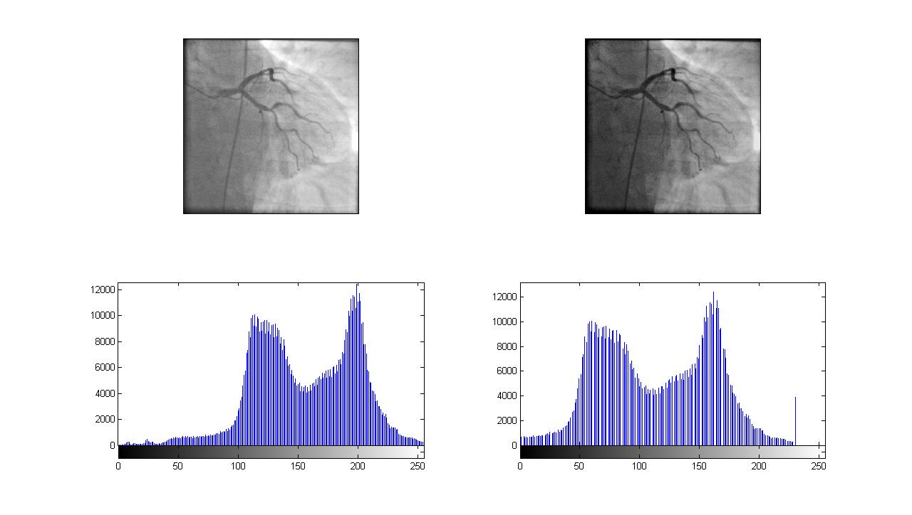

Figure 1.

We can obtain the original image by applying the inverse of the transformation:

f = @( pto ) pto.* (high_out-low_out)/(high_in-low_in) – low_in*k

The standard deviation of the difference between corresponding points was caculated and the error was 1 pixel.

**Exercise 3**

With RGB normalization we get free of distortions caused by lights and shadows in an image by means of taking the intensity of each component of color (R, G and B) to be compere with the others intensities at the same pixel.